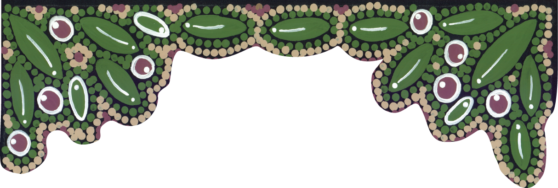

Gold Coast

Karulbo Aboriginal & Torres Strait Islander
Health Partnership

Community Dinner
Featuring Slip on Stereo

19th June 2015
6.30 – 10.00 pm
Paradise Showroom, Gold Coast Arts Centre
135 Bundall Road, Surfers Paradise
DRESS: Cocktail

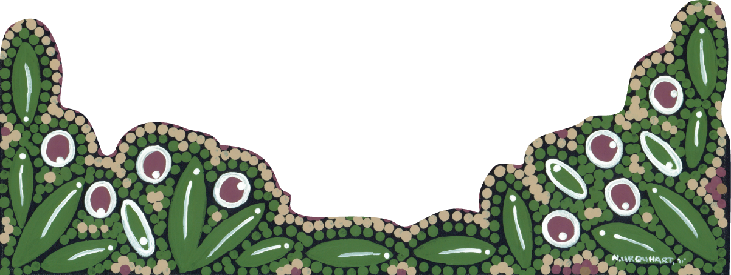
Event will be ticketed.
RSVP’s essential by 8 June 2015 to Indigenous_health_service@health.qld.gov.au or phone 07 55 255630
Artist: N Urquhart for the Karulbo Partnership

